LAPORAN PRAKTIKUM
SISTEM OPERASI



Dosen Pengampu Mata Kuliah:
Triawan Adi Cahyanto, M.K

Disusun Oleh:
Nama : Reflina Anindita
Nim :2410651063

PROGRAM STUDI TEKNIK INFORMATIKA
FAKULTAS TEKNIK
UNIVERSITAS MUHAMMADIYAH JEMBER
2025

Laporan praktikum 1
1.1 Menjelajahi Layanan OS
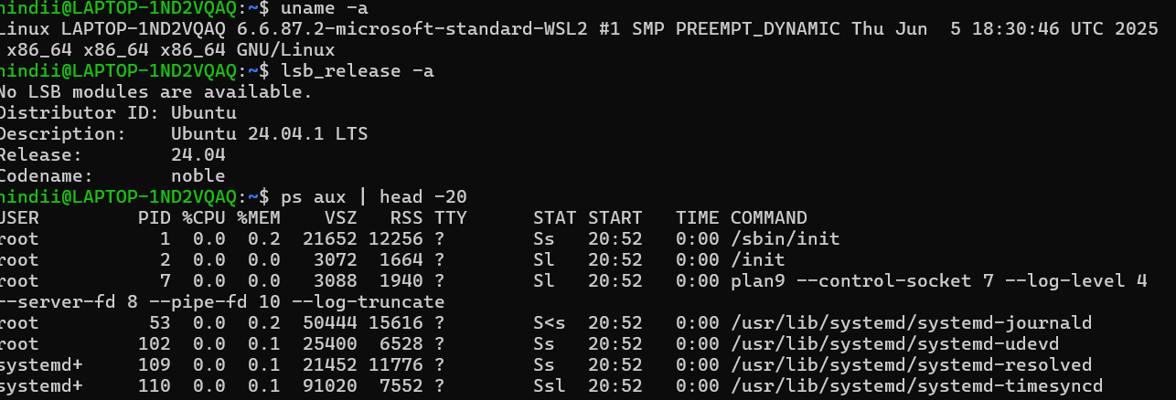
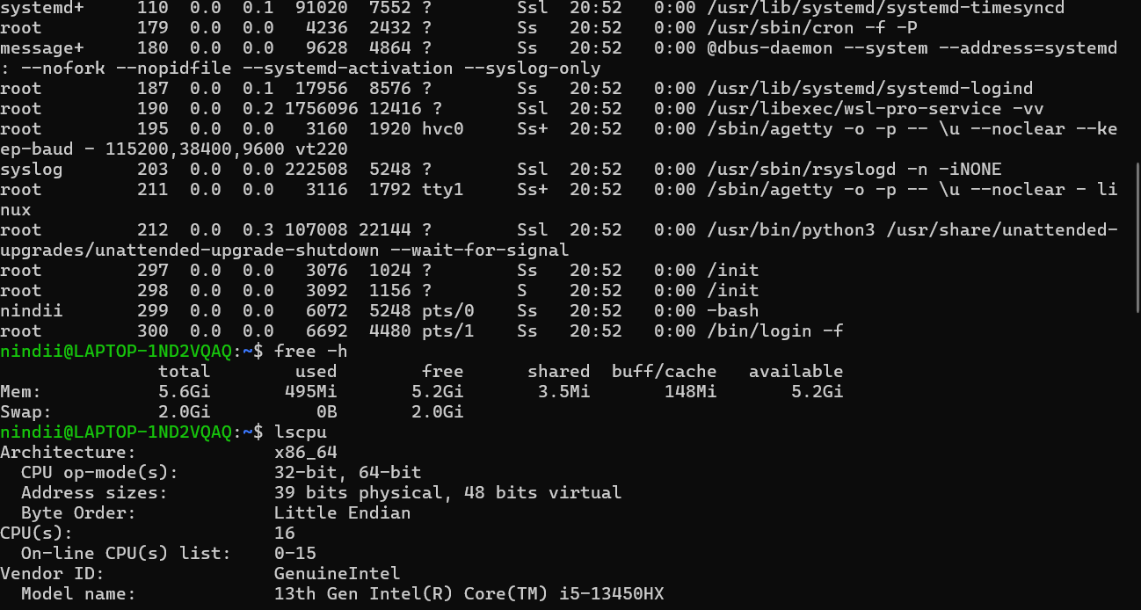
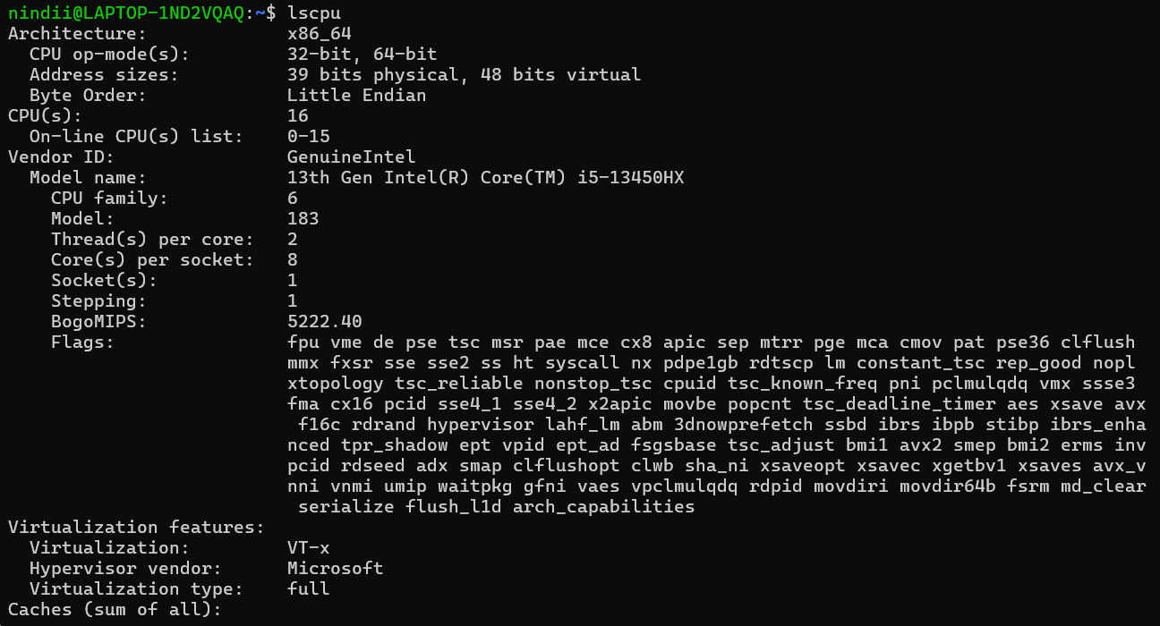
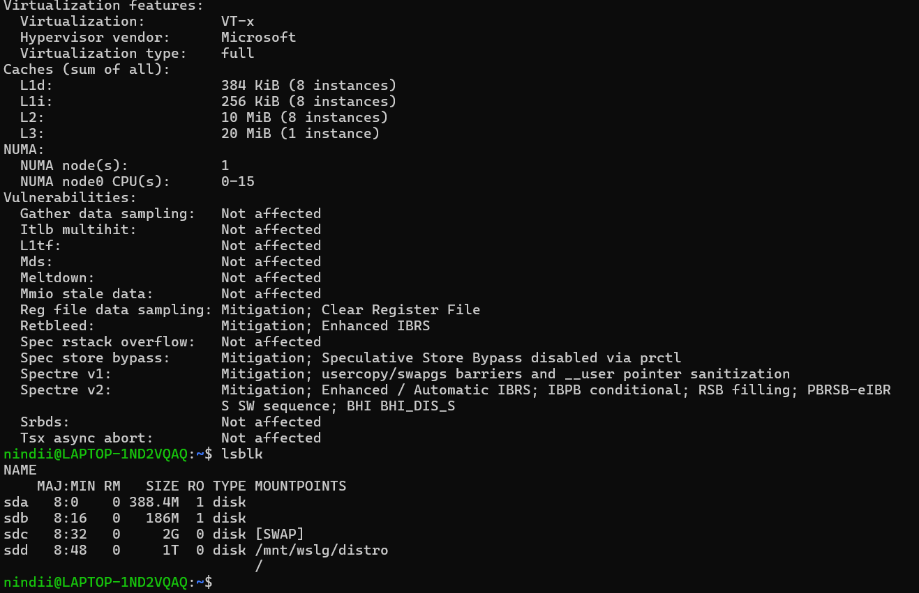

2. User and Operating-System Interface
2.1 Command Line Interface (CLI)
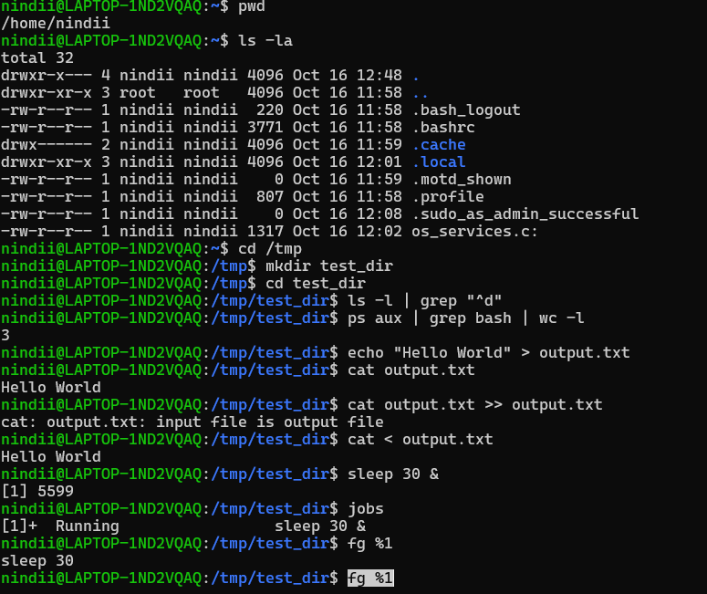
2.2 program C – shell sederhana

3. System Calls
3.1 Process Control System Calls
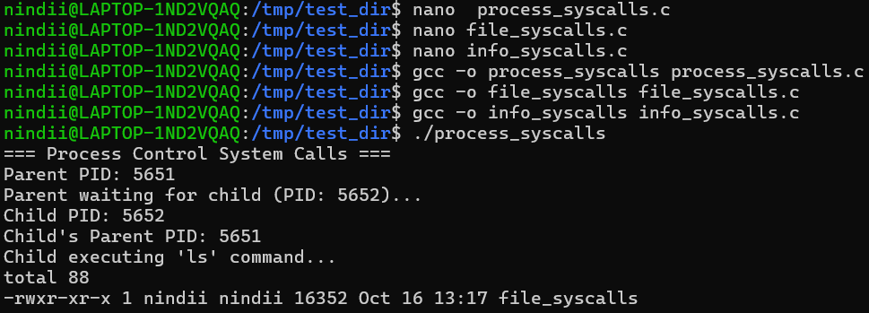
3.2 File Management System Calls

3.3 nformation Maintenance System Calls


- Compile
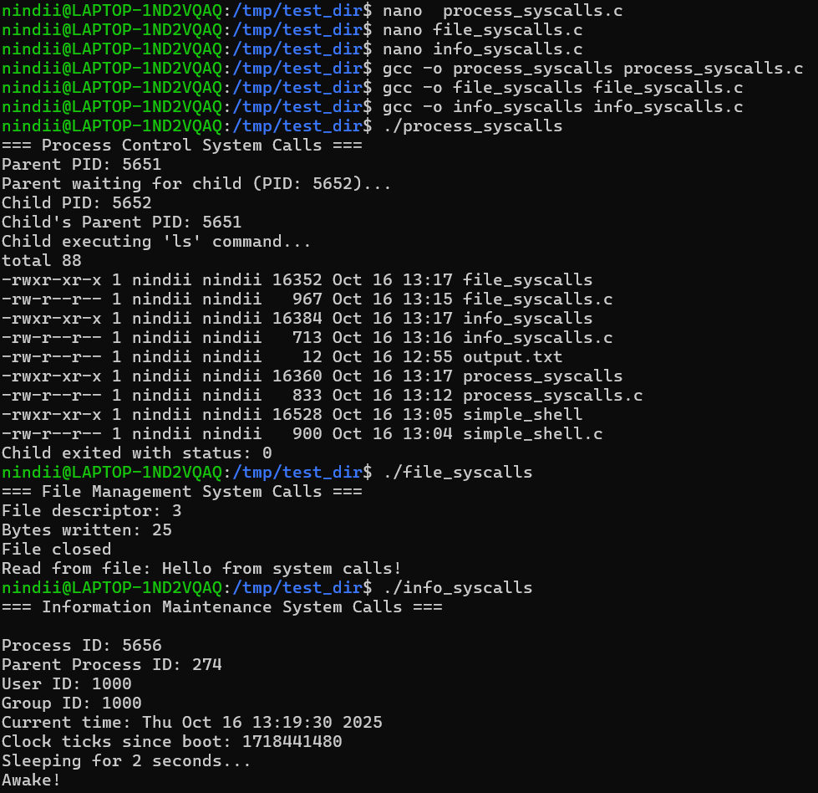

4.2 Membuat Custom System Service
Buat program sederhana my_daemon.c:
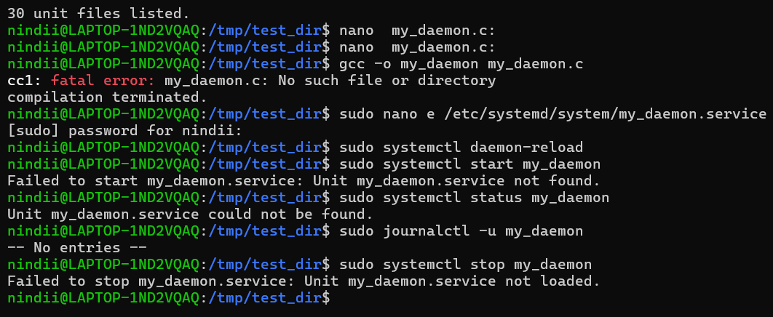
- Compile
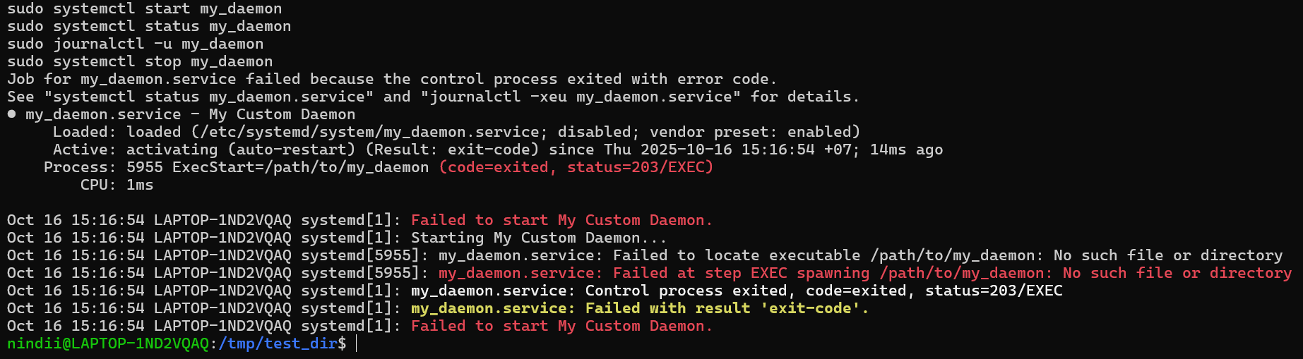
5. Linkers and Loaders Praktik
5.1: Proses Linking
Buat tiga file:
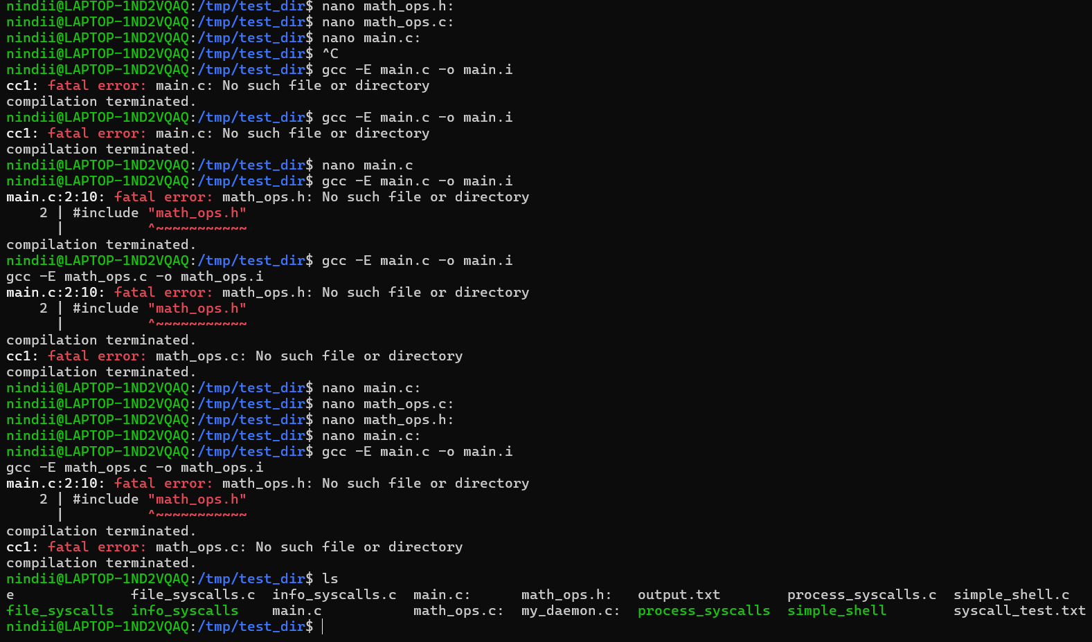

Proses kompilasi bertahap:
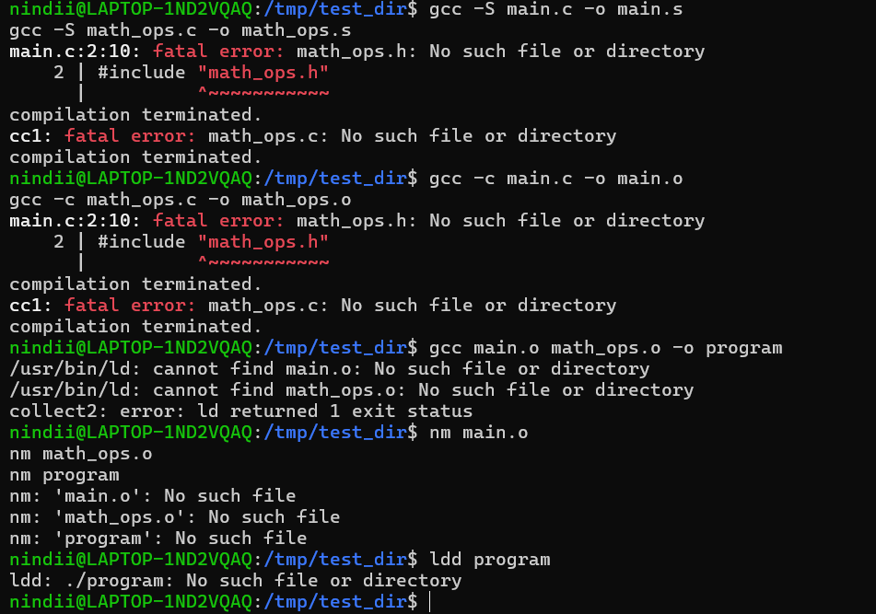
Praktik 5.2: Static vs Dynamic Linking
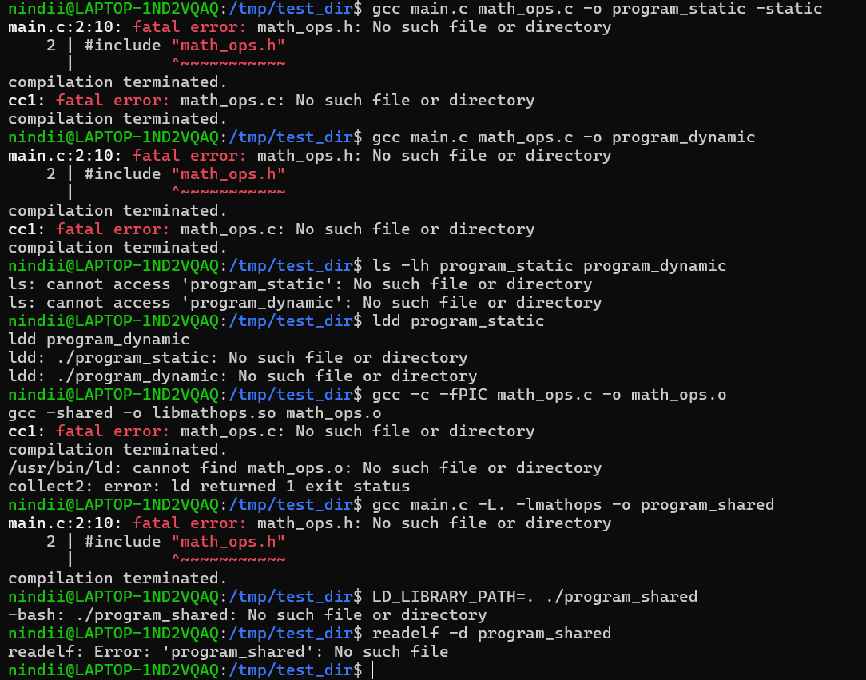
Praktik 5.3: Membuat dan Menggunakan Shared Library

6. Why Applications Are Operating-System Specific Praktik
6.1: System Call Differences
Buat file os_specific.c
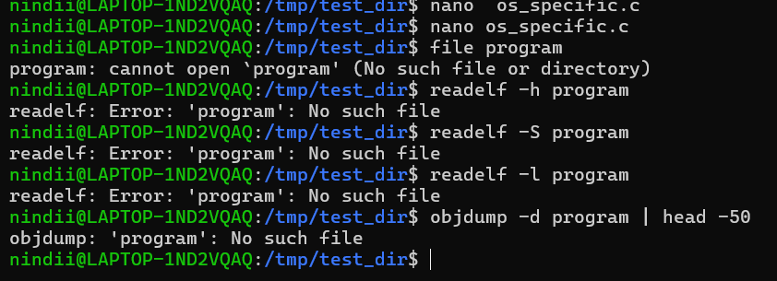
6.2: Binary Format Analysis


7. OS Design and Implementation Praktik
7.1: Kernel Module Sederhana
Buat file hello_module.c:
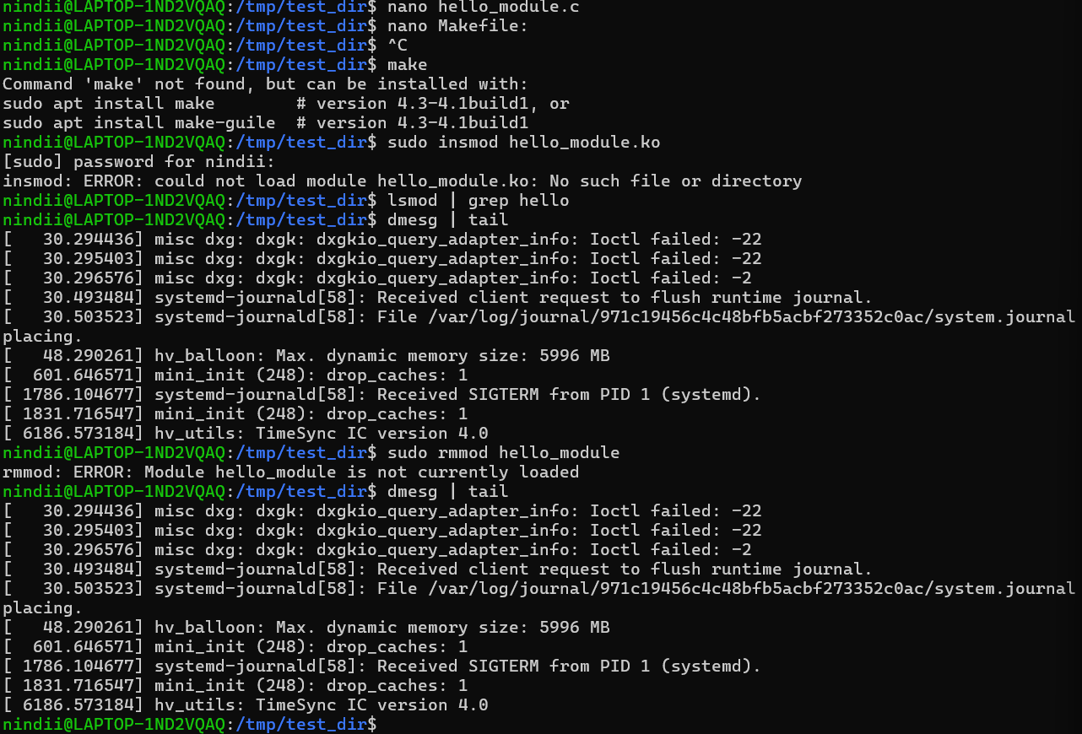
  - Compile and load


Praktik 7.2: Monitoring Kernel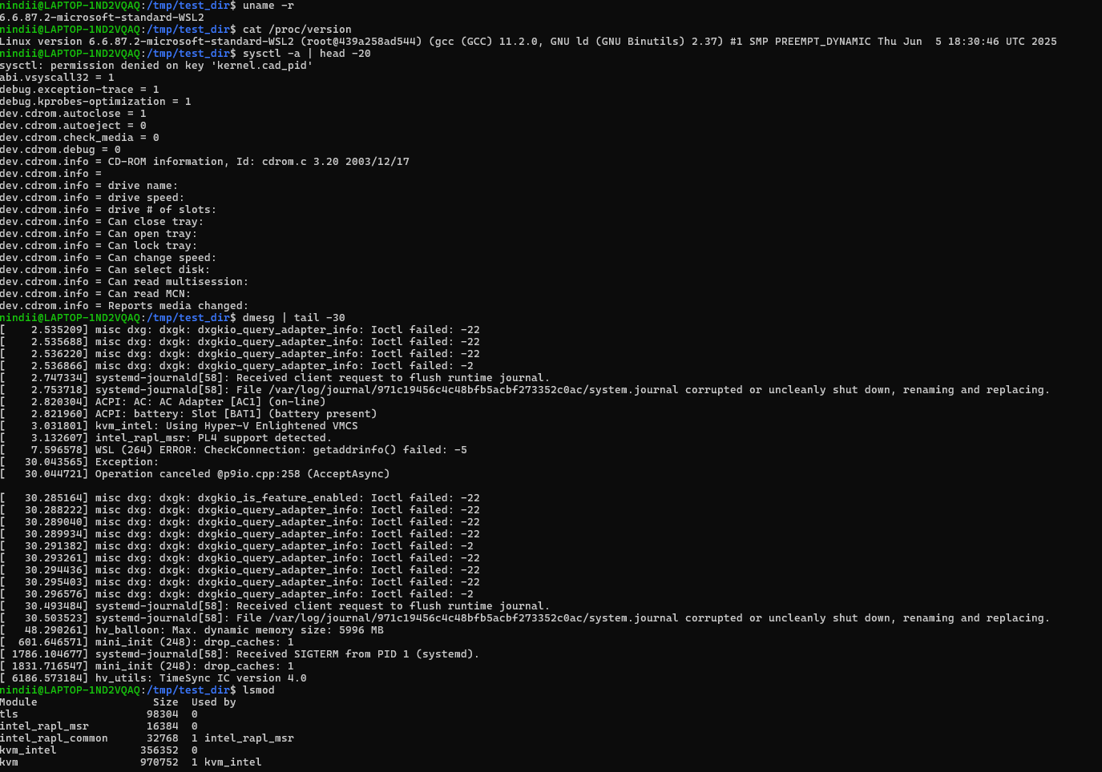
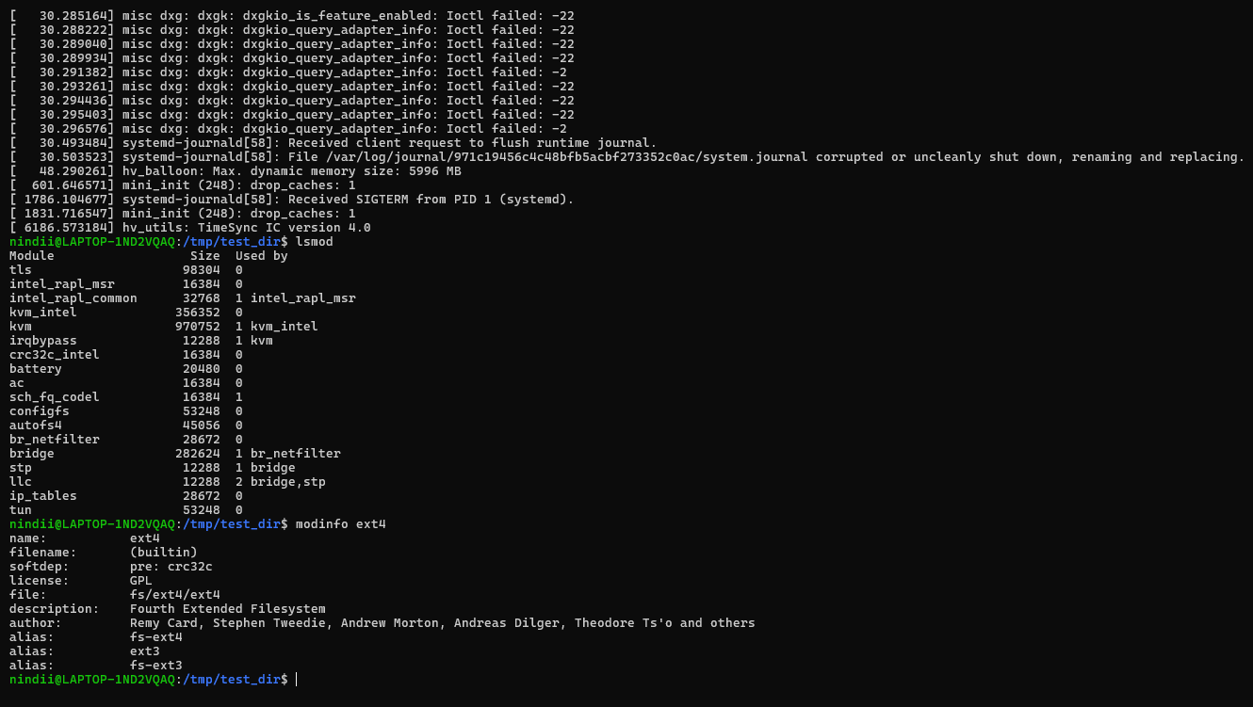

8. Operating-System Structure
Praktik 8.1: Eksplorasi Struktur Layering
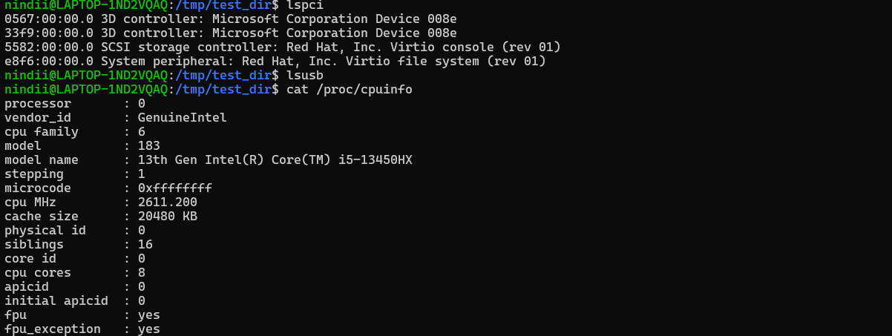
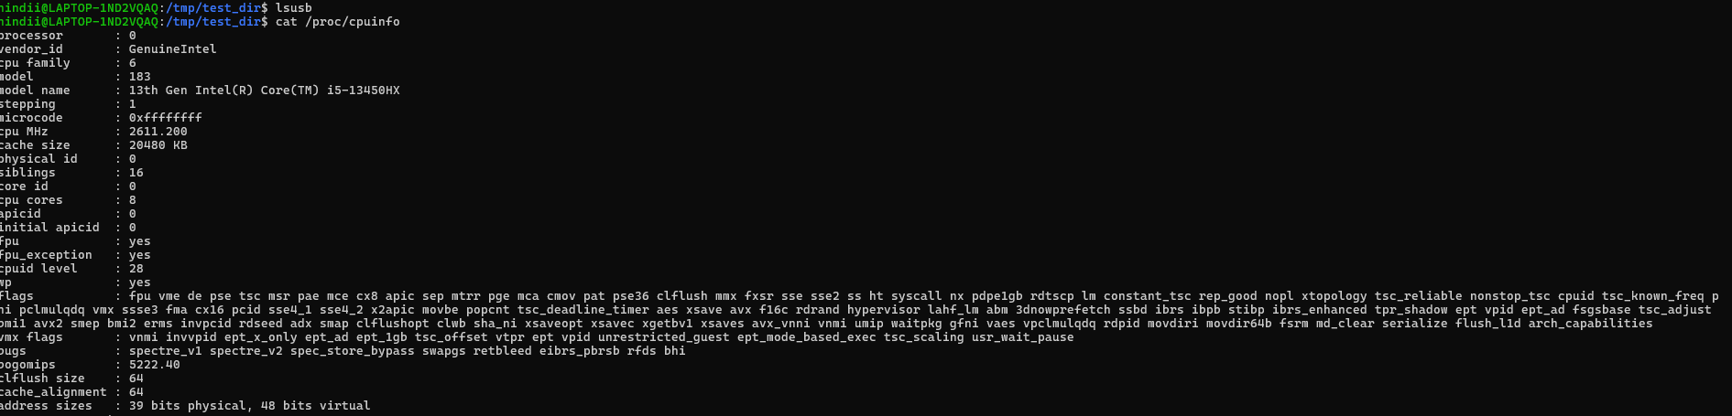
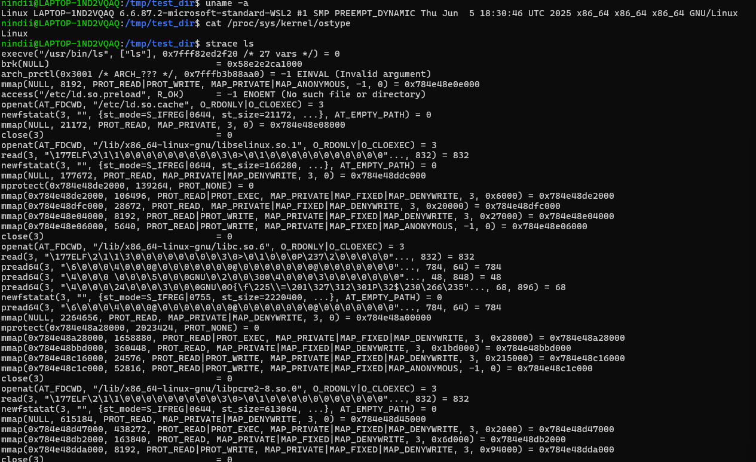
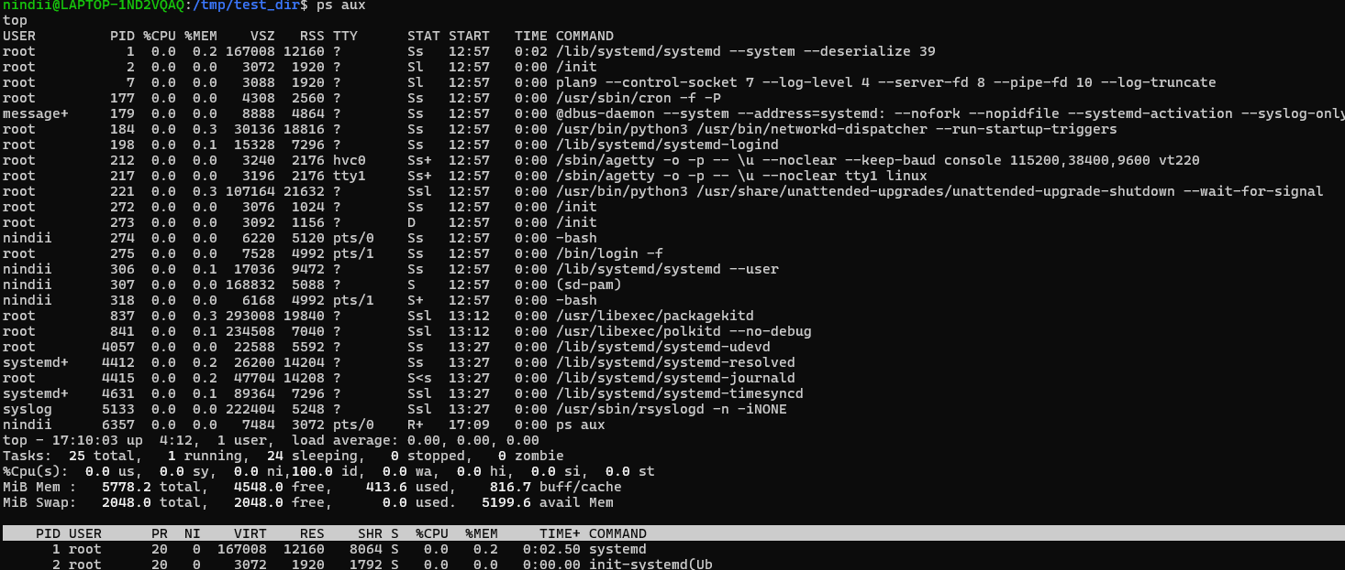

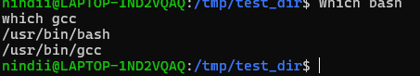

Praktik 8.2: Microkernel vs Monolithic
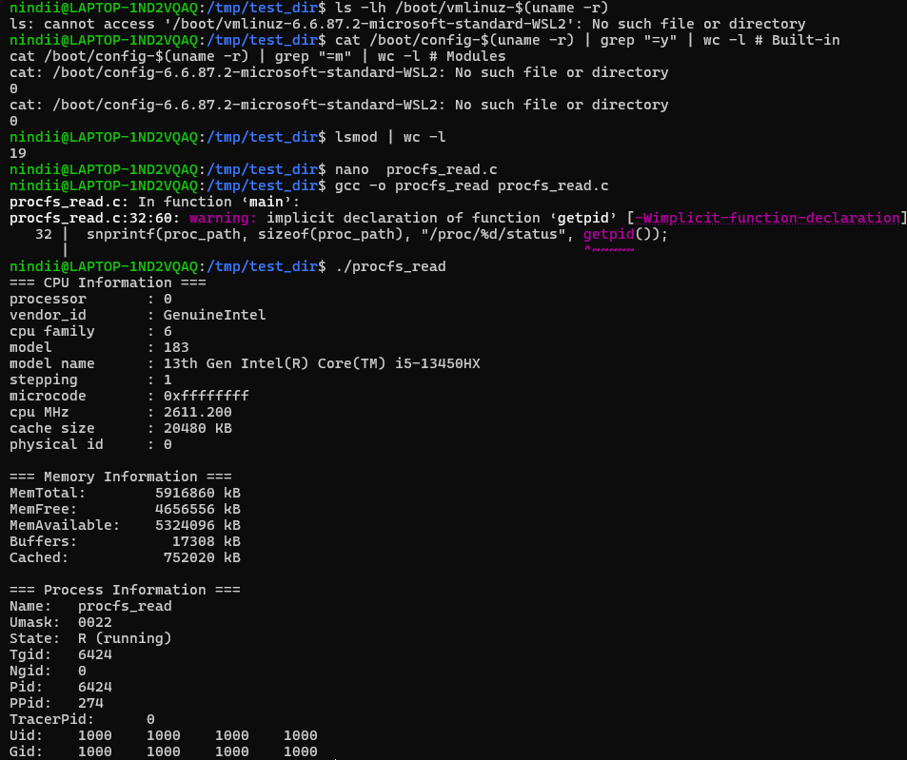

Praktik 8.3: Program - Virtual File System
Buat file procfs_read.c:


9. Building and Booting an Operating System
Praktik 9.1: Analisis Boot Process
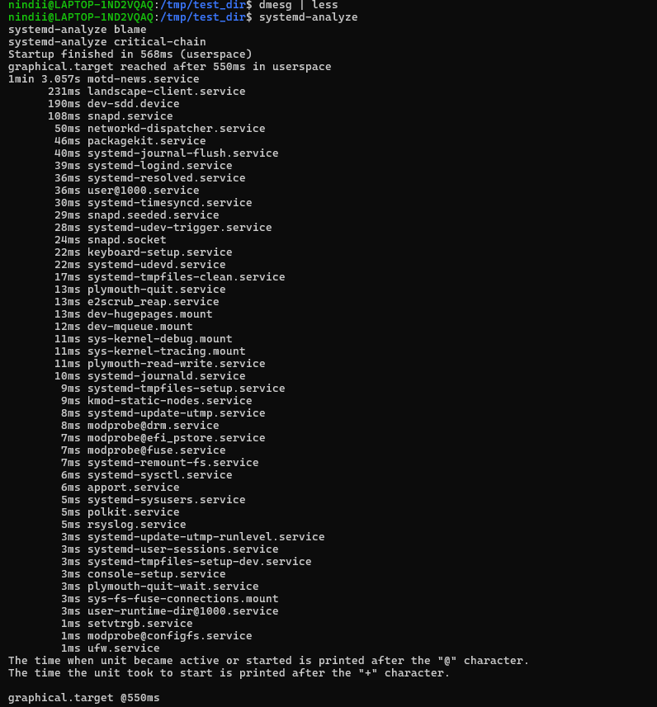
9.2 kernel parameters
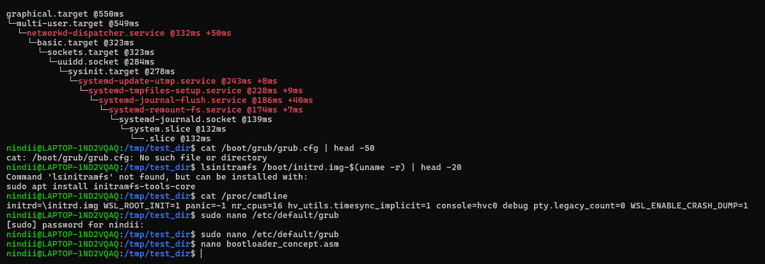

10. Operating-System Debugging
Praktik 10.1: Using strace
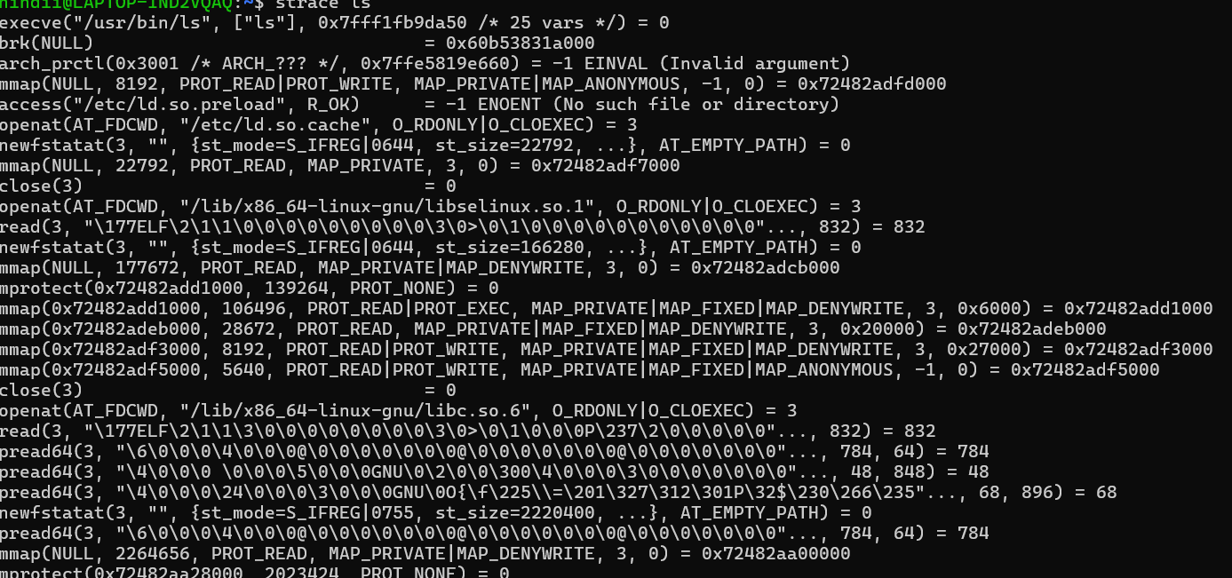
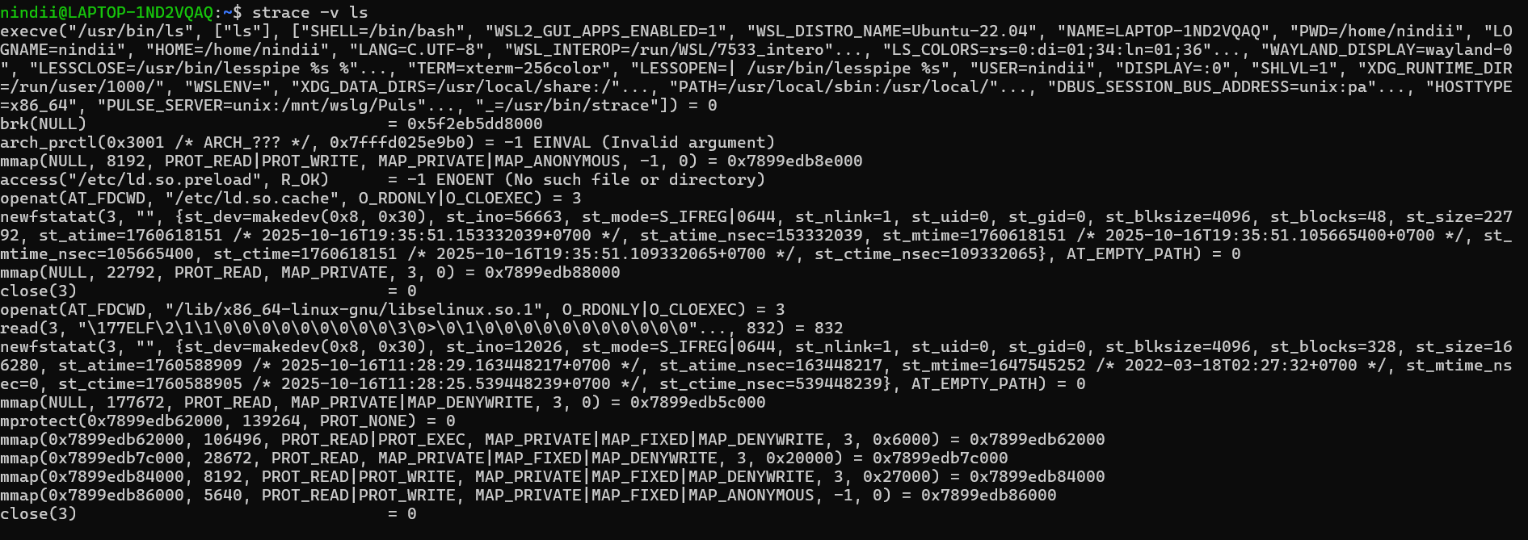
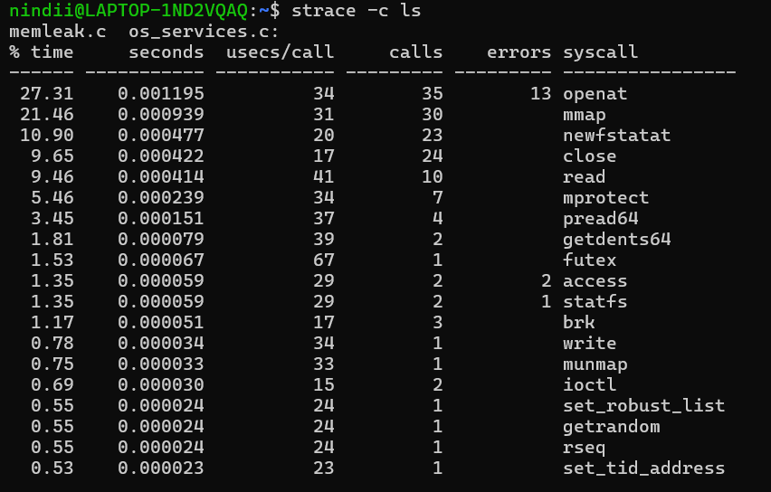
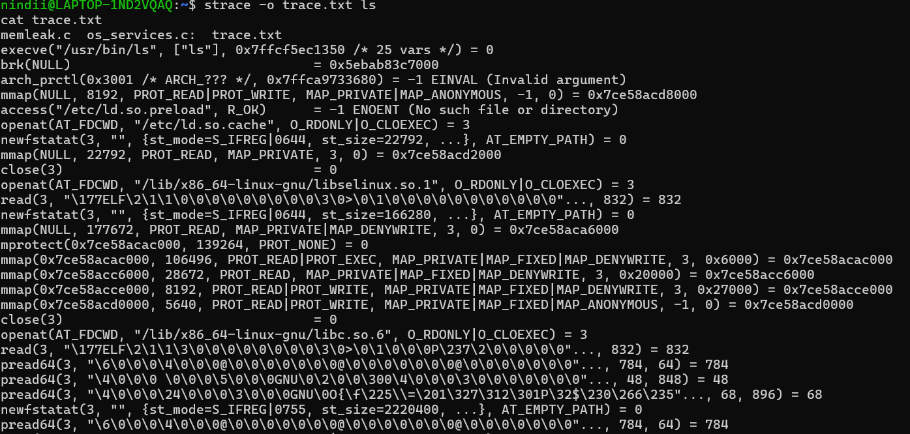
Praktik 10.2: Using ltrace
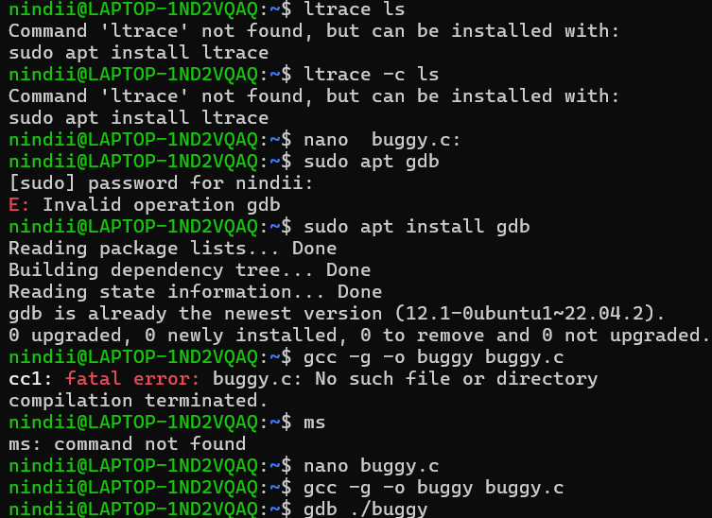
Praktik 10.3: Using GDB
Buat program dengan bug buggy.c:
Debug dengan GDB
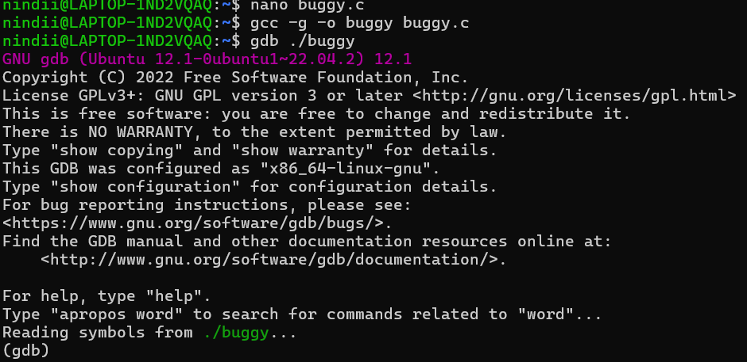

Praktik 10.5: Memory Leak Detection dengan Valgrind
(install valgrind)
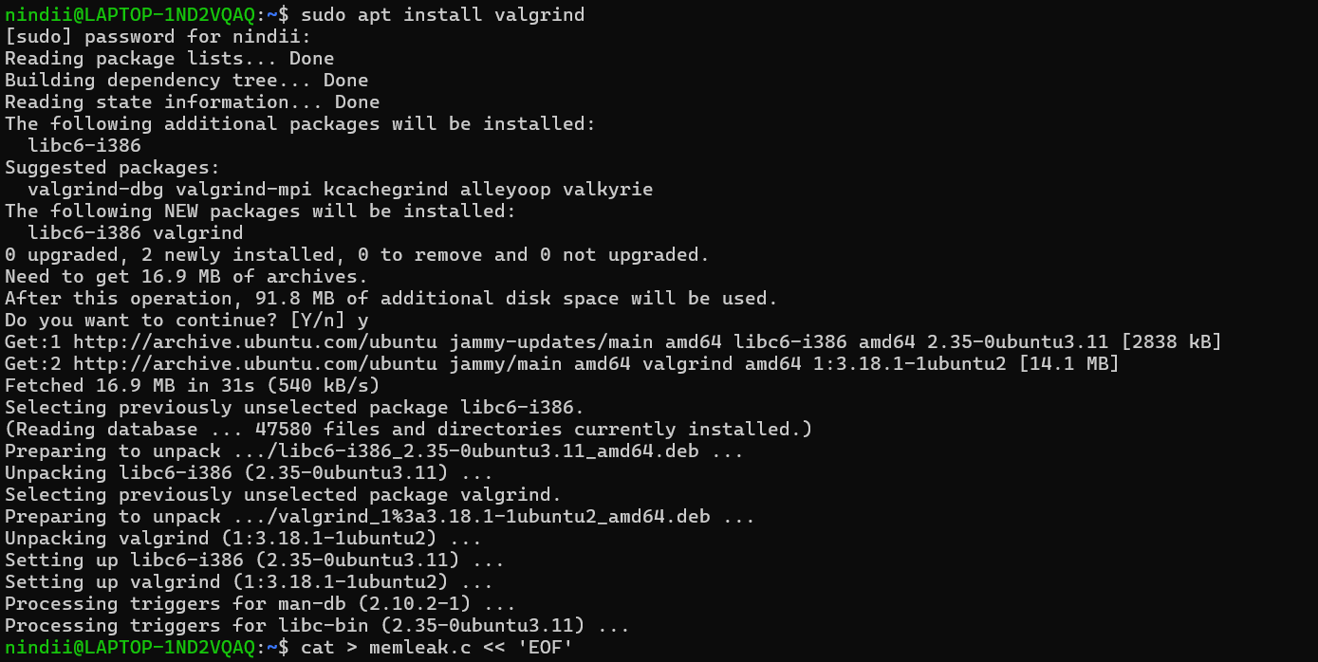

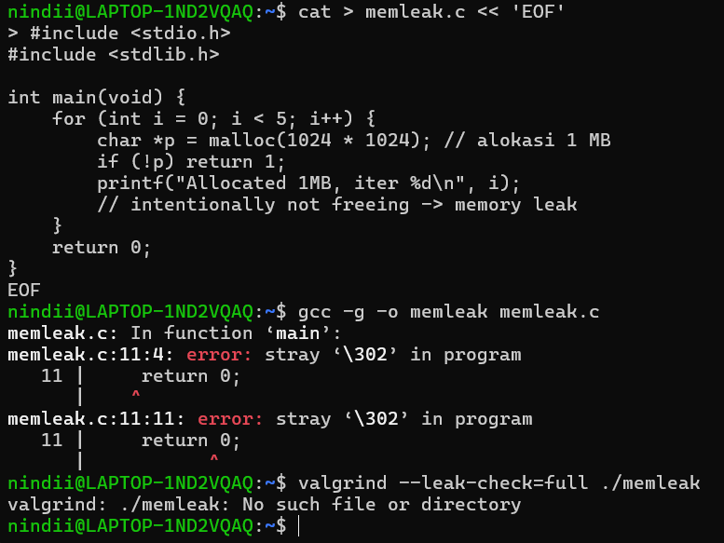
Praktik 10.6: Performance Analysis
